The script will accomplish the following:
1. Read in the jpg image OrangeFlower (available from course webpage.)

To read an image in Matlab, I first saved the picture in the Matlab folder and then assigned it to a variable A as shown below.

>> A=imread('OrangeFlower.jpg');

2. Display the image with the title 'Orange Flower'.

To display the image I used the function shown below.
>> figure, imshow(A);title('Orange Flower');
>>
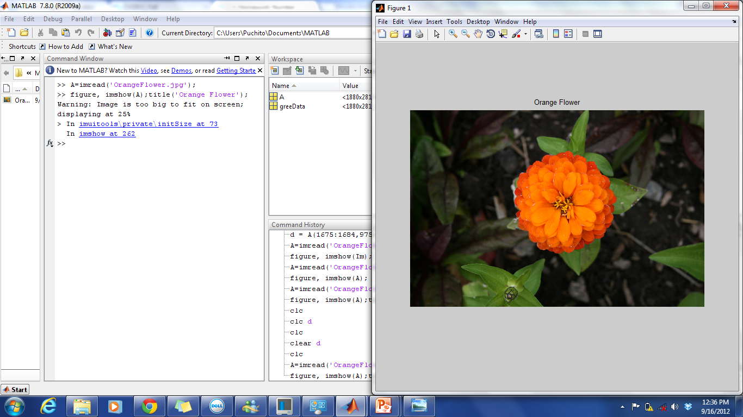
3. Display only the green pixel plane of the image and title Orange Flower Green Pixel Data.

To display the grin pixel in a gray scale I used the following function.
>> figure, imshow(A(:,:,2));title('Orange Flower Green Pixel Data');
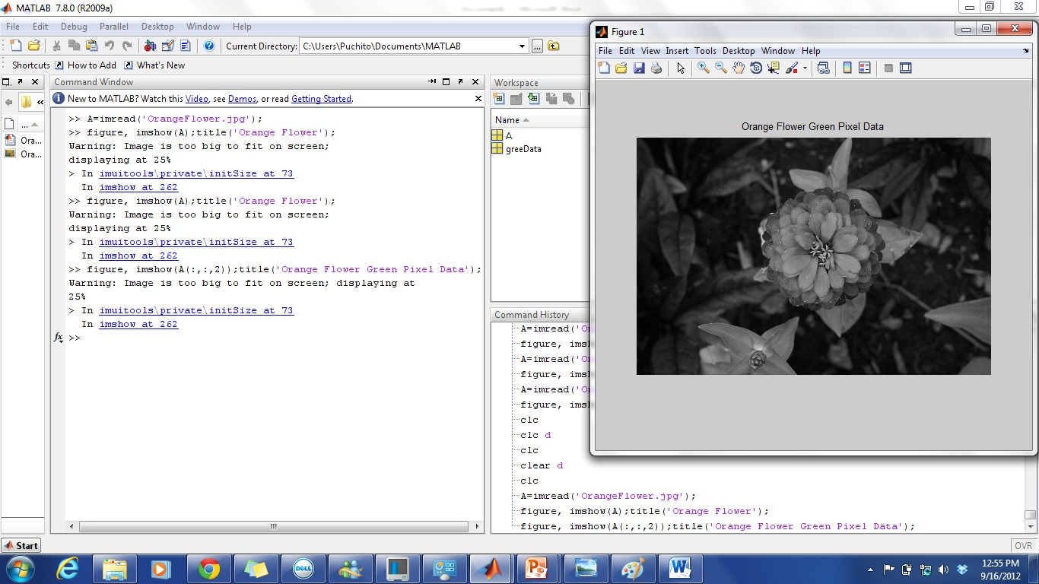
>> figure, imshow(A(:,:,2)), colormap([zeros(256,1),[0:1/255:1]', zeros(256,1)]), colorbar;title('Orange Flower Green Pixel Data');

Now, to display the green pixel in color it was necessary for me to use the colormap function and assign the zeros matrix corresponding to the color green to display as shown below.
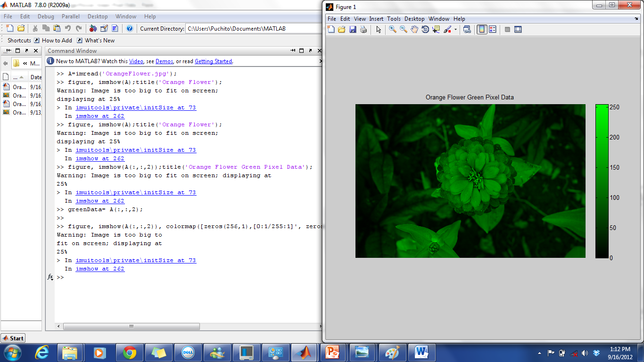

4. Assign the green pixel plane of data to variable greenData.
In the following step I am saving the matrix of green pixels to a variable called greenData.
>> greenData= A(:,:,2);
>>

5. Using Matlab's colon operator ( no loops) extract rows 1675 to 1684 (inclusive) and columns 975 to 984 (inclusive) of the matrix greenData. Assign this region to variable im.
>> im = greenData(1675:1684,975:984);

This function is extracting the assigned rows and colums from the matrix greenData.. As a result, a matrix 10 x 10 is being saved in the variable im.

6. Display the values of the elements (NOT AN IMAGE) of the matrix im to the screen.
>> display(im);

im =
192 194 199 201 199 197 200 198 195 192
195 194 200 203 201 199 200 200 196 193
199 194 198 203 202 200 202 202 200 198
202 194 199 205 206 204 204 203 202 201
204 198 201 206 207 205 205 204 204 203
206 202 201 207 208 208 208 207 207 206
209 205 201 205 211 209 206 208 207 201
210 206 203 204 208 210 209 208 207 207
211 208 207 204 207 211 211 209 207 209
212 210 207 204 206 208 208 207 205 206
>>
Displaying the matrix extracted from the matrix greenData.

7. Use Matlab's min and max functions to find the minimum and maximum values of im. Assign the values to minValue and maxValue. Display these values to the screen (these should each only be a single value. If you cannot get this to work properly, use the help function to obtain additional information on the min and max functions.)

>> minValue=min(im(:));
>> maxValue=max(im(:));
>> display(minValue);
minValue =
192
>> display(maxValue);
maxValue =
212
>>
The above two functions are accessing the minimum and maximum value of the matrix named im and saving them in a variable to display.

8. Multiply each value in im by 2(do not use loops to accomplish this). Assign the result to variable im2.
>> im2= im*2;
Multiplying each element of the matrix named im by 2.

9. Display the values of the elements in im2. Are the results what you expected? EXPLAIN YOUR RESULTS IN THE WRITE-UP PORTION OF THIS ASSIGNMENT.
>> display(im2);
im2 =
255 255 255 255 255 255 255 255 255 255
255 255 255 255 255 255 255 255 255 255
255 255 255 255 255 255 255 255 255 255
255 255 255 255 255 255 255 255 255 255
255 255 255 255 255 255 255 255 255 255
255 255 255 255 255 255 255 255 255 255
255 255 255 255 255 255 255 255 255 255
255 255 255 255 255 255 255 255 255 255
255 255 255 255 255 255 255 255 255 255
255 255 255 255 255 255 255 255 255 255
>>
Results are explained separately as requested.

10. Use Matlab's double function to convert im to double. Assign the results to variable imDouble1. Display the values of the elements in imDouble1.

>> imDouble1= double(im)

imDouble1 =

192 194 199 201 199 197 200 198 195 192
195 194 200 203 201 199 200 200 196 193
199 194 198 203 202 200 202 202 200 198
202 194 199 205 206 204 204 203 202 201
204 198 201 206 207 205 205 204 204 203
206 202 201 207 208 208 208 207 207 206
209 205 201 205 211 209 206 208 207 201
210 206 203 204 208 210 209 208 207 207
211 208 207 204 207 211 211 209 207 209
212 210 207 204 206 208 208 207 205 206
>>
Converting the matrix named im from a matrix of class single to a matrix of class double, which will allow a greater range of the matrix in case values increment.

11. Multiply each value in imDouble1 by 2. Assign your results to imDouble12.
>> imDouble12= imDouble1*2;
>>
Multiplying each element of the matrix named imDouble12 by 2.

12. Display the values of the elements in imDouble12. How do they differ from im2. EXPLAIN YOUR RESULTS IN THE WRITE-UP PORTION OF THIS ASSIGNMENT.
>> display(imDouble12);

imDouble12 =

384 388 398 402 398 394 400 396 390 384
390 388 400 406 402 398 400 400 392 386
398 388 396 406 404 400 404 404 400 396
404 388 398 410 412 408 408 406 404 402
408 396 402 412 414 410 410 408 408 406
412 404 402 414 416 416 416 414 414 412
418 410 402 410 422 418 412 416 414 402
420 412 406 408 416 420 418 416 414 414
422 416 414 408 414 422 422 418 414 418
424 420 414 408 412 416 416 414 410 412
>>
Results are explained separately as requested.

13. Use Matlab's im2double function to convert im to double. Assign the results to variable imDouble2.
>> imDouble2= im2double(im);

Converting the matrix named im from a matrix of class single to a matrix of class double, while offsetting its matrix values to a range of (0-1).
14. Display the values in imDouble2. How do they differ from Double1. EXPLAIN YOUR RESULTS IN THE WRITE-UP PORTION OF THIS ASSIGNMENT.
>> display(imDouble2);

imDouble2 =

Columns 1 through 6

0.7529 0.7608 0.7804 0.7882 0.7804 0.7725
0.7647 0.7608 0.7843 0.7961 0.7882 0.7804
0.7804 0.7608 0.7765 0.7961 0.7922 0.7843
0.7922 0.7608 0.7804 0.8039 0.8078 0.8000
0.8000 0.7765 0.7882 0.8078 0.8118 0.8039
0.8078 0.7922 0.7882 0.8118 0.8157 0.8157
0.8196 0.8039 0.7882 0.8039 0.8275 0.8196
0.8235 0.8078 0.7961 0.8000 0.8157 0.8235
0.8275 0.8157 0.8118 0.8000 0.8118 0.8275
0.8314 0.8235 0.8118 0.8000 0.8078 0.8157

Columns 7 through 10

0.7843 0.7765 0.7647 0.7529
0.7843 0.7843 0.7686 0.7569
0.7922 0.7922 0.7843 0.7765
0.8000 0.7961 0.7922 0.7882
0.8039 0.8000 0.8000 0.7961
0.8157 0.8118 0.8118 0.8078
0.8078 0.8157 0.8118 0.7882
0.8196 0.8157 0.8118 0.8118
0.8275 0.8196 0.8118 0.8196
0.8157 0.8118 0.8039 0.8078
>>
Displaying results from previous question.
15 Use Matlab's mat2gray to convert im to type double. Assign the result to variable imDouble3. Display the elements in imDouble3. How do they differ from imDouble2? EXPLAIN YOUR RESULTS IN THE WRITE-UP PORTION OF THIS ASSIGNMENT.
>> imDouble3= mat2gray(im)

imDouble3 =

Columns 1 through 6

0 0.1000 0.3500 0.4500 0.3500 0.2500
0.1500 0.1000 0.4000 0.5500 0.4500 0.3500
0.3500 0.1000 0.3000 0.5500 0.5000 0.4000
0.5000 0.1000 0.3500 0.6500 0.7000 0.6000
0.6000 0.3000 0.4500 0.7000 0.7500 0.6500
0.7000 0.5000 0.4500 0.7500 0.8000 0.8000
0.8500 0.6500 0.4500 0.6500 0.9500 0.8500
0.9000 0.7000 0.5500 0.6000 0.8000 0.9000
0.9500 0.8000 0.7500 0.6000 0.7500 0.9500
1.0000 0.9000 0.7500 0.6000 0.7000 0.8000

Columns 7 through 10

0.4000 0.3000 0.1500 0
0.4000 0.4000 0.2000 0.0500
0.5000 0.5000 0.4000 0.3000
0.6000 0.5500 0.5000 0.4500
0.6500 0.6000 0.6000 0.5500
0.8000 0.7500 0.7500 0.7000
0.7000 0.8000 0.7500 0.4500
0.8500 0.8000 0.7500 0.7500
0.9500 0.8500 0.7500 0.8500
0.8000 0.7500 0.6500 0.7000
>>
Results are explained separately as requested.

Write Up

9. Display the values of the elements in im2. Are the results what you expected?
>> display(im2);
im2 =
255 255 255 255 255 255 255 255 255 255
255 255 255 255 255 255 255 255 255 255
255 255 255 255 255 255 255 255 255 255
255 255 255 255 255 255 255 255 255 255
255 255 255 255 255 255 255 255 255 255
255 255 255 255 255 255 255 255 255 255
255 255 255 255 255 255 255 255 255 255
255 255 255 255 255 255 255 255 255 255
255 255 255 255 255 255 255 255 255 255
255 255 255 255 255 255 255 255 255 255

No, I was expecting the data to be the double of what the original data, the matrix im, and not 255 as we can see above. However, this result can be explained s following. The matrix im is a single precision matrix. This means, that the bits of this matrix has a limit rage of magnitudes in which the values of the actual matrix cannot be represented.

12. Display the values of the elements in imDouble12. How do they differ from im2.
>> display(imDouble12);

imDouble12 =

384 388 398 402 398 394 400 396 390 384
390 388 400 406 402 398 400 400 392 386
398 388 396 406 404 400 404 404 400 396
404 388 398 410 412 408 408 406 404 402
408 396 402 412 414 410 410 408 408 406
412 404 402 414 416 416 416 414 414 412
418 410 402 410 422 418 412 416 414 402
420 412 406 408 416 420 418 416 414 414
422 416 414 408 414 422 422 418 414 418
424 420 414 408 412 416 416 414 410 412
>>
imDouble12 is the im2 matrix converted into a double precision matrix. The above result proves the following; the double-precision values of the matrix im2 use twice as many bits as the matrix im2. The extra bits increase not only the precision but also the range of magnitudes that the matrix is being represented with.

14. Display the values in imDouble2. How do they differ from Double1.
>> display(imDouble2);

imDouble2 =

Columns 1 through 6

0.7529 0.7608 0.7804 0.7882 0.7804 0.7725
0.7647 0.7608 0.7843 0.7961 0.7882 0.7804
0.7804 0.7608 0.7765 0.7961 0.7922 0.7843
0.7922 0.7608 0.7804 0.8039 0.8078 0.8000
0.8000 0.7765 0.7882 0.8078 0.8118 0.8039
0.8078 0.7922 0.7882 0.8118 0.8157 0.8157
0.8196 0.8039 0.7882 0.8039 0.8275 0.8196
0.8235 0.8078 0.7961 0.8000 0.8157 0.8235
0.8275 0.8157 0.8118 0.8000 0.8118 0.8275
0.8314 0.8235 0.8118 0.8000 0.8078 0.8157

Columns 7 through 10

0.7843 0.7765 0.7647 0.7529
0.7843 0.7843 0.7686 0.7569
0.7922 0.7922 0.7843 0.7765
0.8000 0.7961 0.7922 0.7882
0.8039 0.8000 0.8000 0.7961
0.8157 0.8118 0.8118 0.8078
0.8078 0.8157 0.8118 0.7882
0.8196 0.8157 0.8118 0.8118
0.8275 0.8196 0.8118 0.8196
0.8157 0.8118 0.8039 0.8078
>>

The im2double takes the matrix as input and returns a matrix of class double. If the input image is of class double, the output image is identical to it. But since the input matrix is not double, im2double is returning a rescaled equivalent matrix of class double. On the other hand, double is only returning an equivalent matrix of class double.

15 Use Matlab's mat2gray to convert im to type double. Assign the result to variable imDouble3. Display the elements in imDouble3. How do they differ from imDouble2?
>> imDouble3= mat2gray(im)

imDouble3 =

Columns 1 through 6

0 0.1000 0.3500 0.4500 0.3500 0.2500
0.1500 0.1000 0.4000 0.5500 0.4500 0.3500
0.3500 0.1000 0.3000 0.5500 0.5000 0.4000
0.5000 0.1000 0.3500 0.6500 0.7000 0.6000
0.6000 0.3000 0.4500 0.7000 0.7500 0.6500
0.7000 0.5000 0.4500 0.7500 0.8000 0.8000
0.8500 0.6500 0.4500 0.6500 0.9500 0.8500
0.9000 0.7000 0.5500 0.6000 0.8000 0.9000
0.9500 0.8000 0.7500 0.6000 0.7500 0.9500
1.0000 0.9000 0.7500 0.6000 0.7000 0.8000

Columns 7 through 10

0.4000 0.3000 0.1500 0
0.4000 0.4000 0.2000 0.0500
0.5000 0.5000 0.4000 0.3000
0.6000 0.5500 0.5000 0.4500
0.6500 0.6000 0.6000 0.5500
0.8000 0.7500 0.7500 0.7000
0.7000 0.8000 0.7500 0.4500
0.8500 0.8000 0.7500 0.7500
0.9500 0.8500 0.7500 0.8500
0.8000 0.7500 0.6500 0.7000

The im2double function rescaled the matrix pixel values and converted them to a double while the function mat2gray is also returning a rescaled closed image but in a grayscale.

16. In the write up portion of this assignment in addition to describing the results from steps 1-13 above in a separate section summarize the differences between the following Matlab operations:
16a. double
16b im2double
16c. im2double(double(im))
16d. mat2gray

- The double function returns the double precision value of a matrix. If the matrix’s values are already double, double has no effect on them. Unlike single precision, double precision range can exceed (0 – 255).

- Similarly to a double, im2double takes the matrix of the image as input and returns an image of class double. Since the input matrix is not double in this case, im2double returns the equivalent image of class double and rescale or offset the data as necessary within the range (0 -1).

- As mentioned above, the im2double function takes the matrix as input and returns an image matrix of class double. However, since the matrix values are already double in this case, the output matrix of the image is identical to the input matrix.

- mat2gray (A, [AMIN AMAX]) converts the input matrix to the intensity image I. The returned matrix contains values in the range 0.0 (black) to 1.0 (full intensity or white). AMIN and AMAX are the values in the output matrix that correspond to 0.0 and 1.0 in the input matrix. Unlike im2double, in gray scaling values less than AMIN are set to 0.0, and values greater than AMAX are set 1.0.

